**Installing and setting up Kubernetes Minikube**

**Update system packages and Install dependencies**

sudo apt update && sudo apt upgrade -y

sudo apt install -y curl wget apt-transport-https conntrack socat

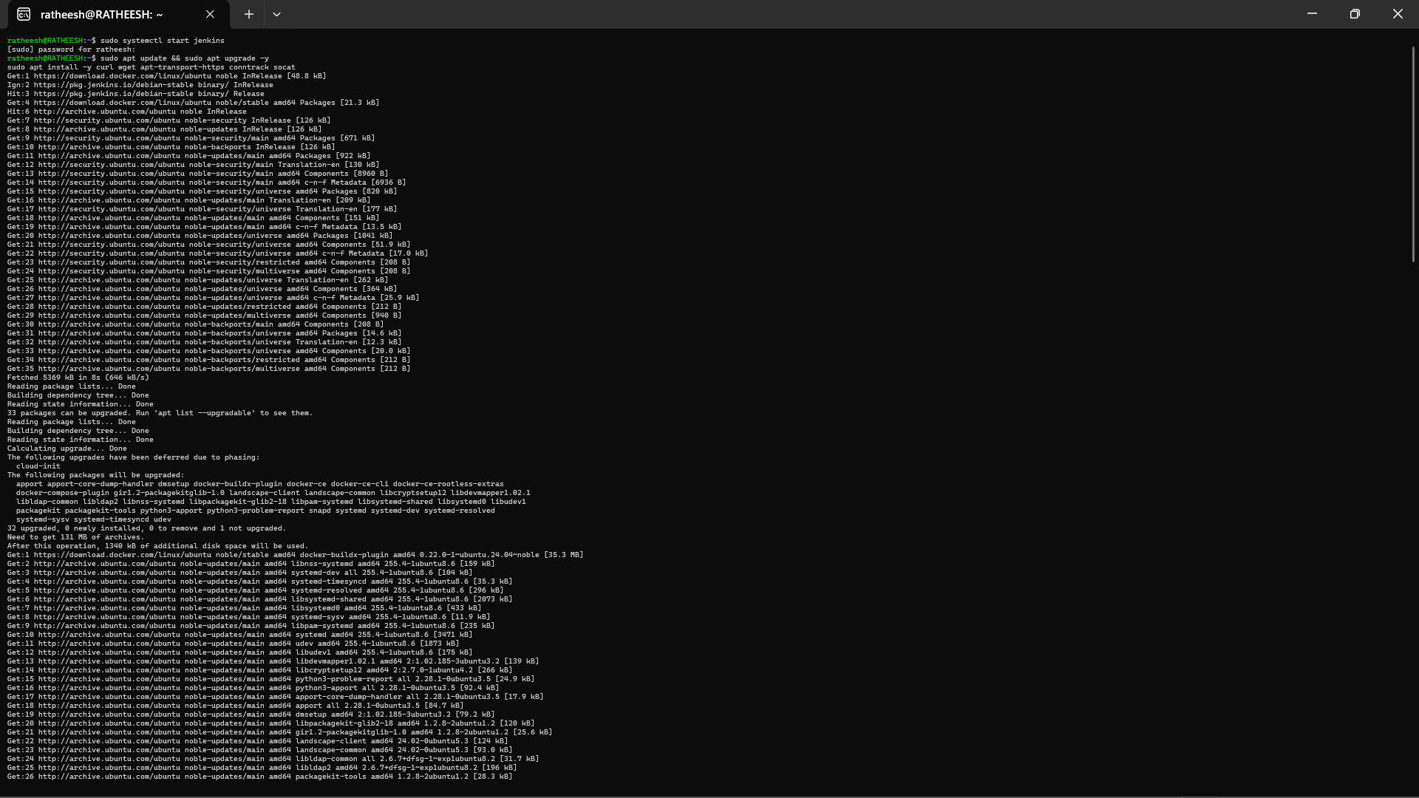

**Install Docker, Kubectl and Minikube**

**Install Docker**

sudo apt install -y docker.io

sudo systemctl start docker

sudo systemctl enable docker

docker --version

**Install Kubectl**

curl -LO "https://dl.k8s.io/release/$(curl -L -s https://dl.k8s.io/release/stable.txt)/bin/linux/amd64/kubectl"

chmod +x kubectl

sudo mv kubectl /usr/local/bin/

kubectl version --client

**Install Minikube**

curl -LO https://storage.googleapis.com/minikube/releases/latest/minikube-linux-amd64

sudo install minikube-linux-amd64 /usr/local/bin/minikube

minikube version

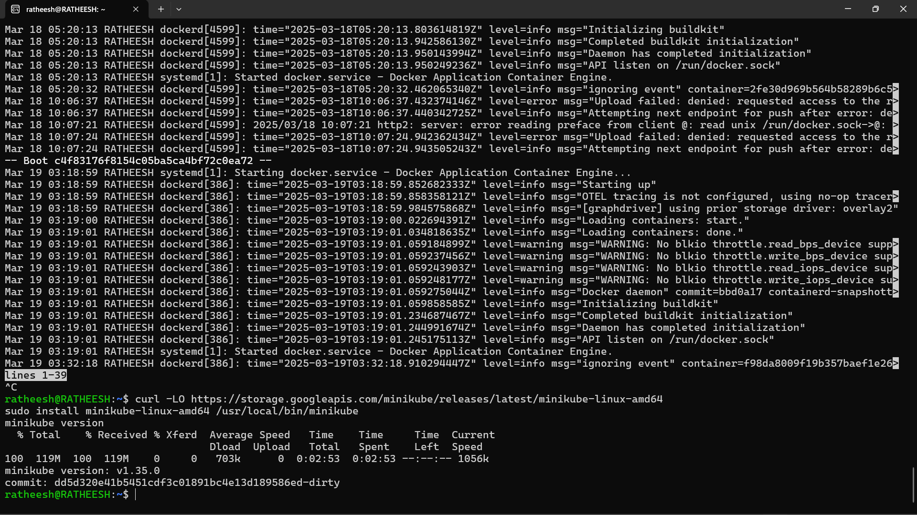

**Fix Docker setup**

sudo usermod -aG docker $USER

reboot

**Verify Installation after reboot**

docker run hello-world

**Start and open Minikube**

minikube start --driver=docker

minikube dashboard

**Deployinig the docker image from dockerhub**

mkdir docker

nano Dockerfile

npm init -y

npm init -y // again if the previous command installed npm

cd ..

docker pull sanjai4334/docker:latest . // replace with your docker uid/repo:image_tag

cd docker

docker build -t sanjai4334/docker/latest

docker ps -a

sudo nano nginx-deployment.yaml

kubectl apply -f nginx-deployment.yaml

sudo nano service.yaml

kubectl apply -f service.yaml

kubectl get pods

minikube get svc my-app

minikube service my-app --url

* open the url in browser

curl <url>